The Egg.

The egg is a reproductive structure produced by females of various animals, including birds, reptiles, amphibians, and some fish.

It is typically a rounded or oval-shaped object with a hard outer shell that provides protection to the developing embryo inside.

Eggs serve as a means of reproduction for many species, containing the nutrients and conditions necessary for the embryo's growth until it is ready to hatch.

In birds, eggs are fertilised internally by mating, and then they are laid and incubated by the female.

The embryo inside the egg is nourished by the contents, and the eggshell helps prevent damage and infection while allowing for gas exchange.

Different species have varying sizes, shapes, and colours of eggs, adapted to their specific reproductive needs and environments.

Below: The eggs of species of fowl commonly kept as poultry.
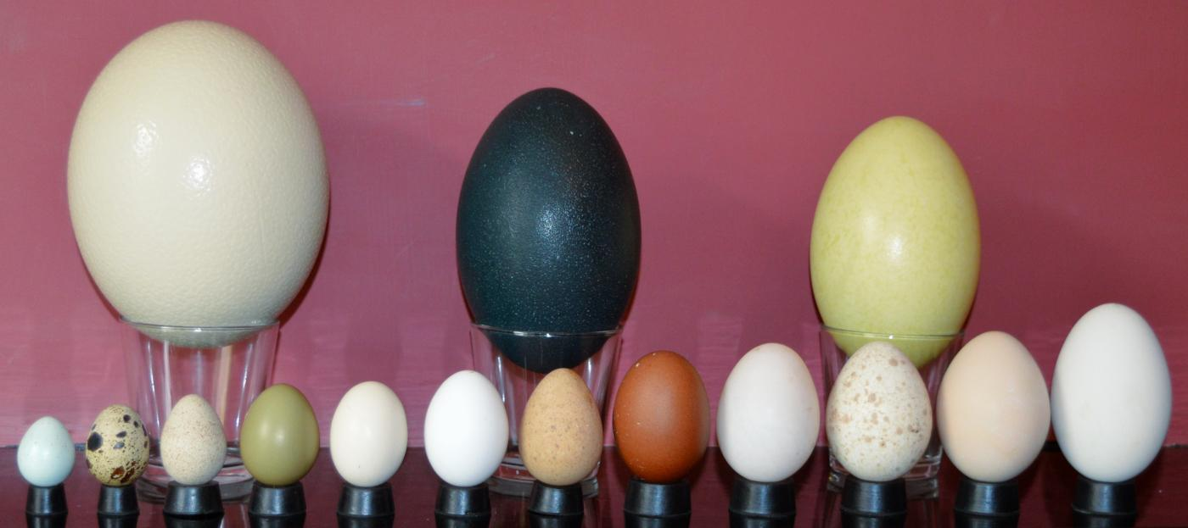
Top: Ostrich, Rhea, Emu.
Bottom: Celadon Quail, Quail, Partridge. Pheasant, True Bantam, Bantam, Guinea fowl, Chicken, Duck, Turkey, Peafowl, Goose.

The global egg consumption in 2021 was estimated to be 161 eggs per person per year, or 1.1 trillion eggs total.
Eggs are a symbol of fertility and new beginnings in many cultures.

The anatomy of the egg.
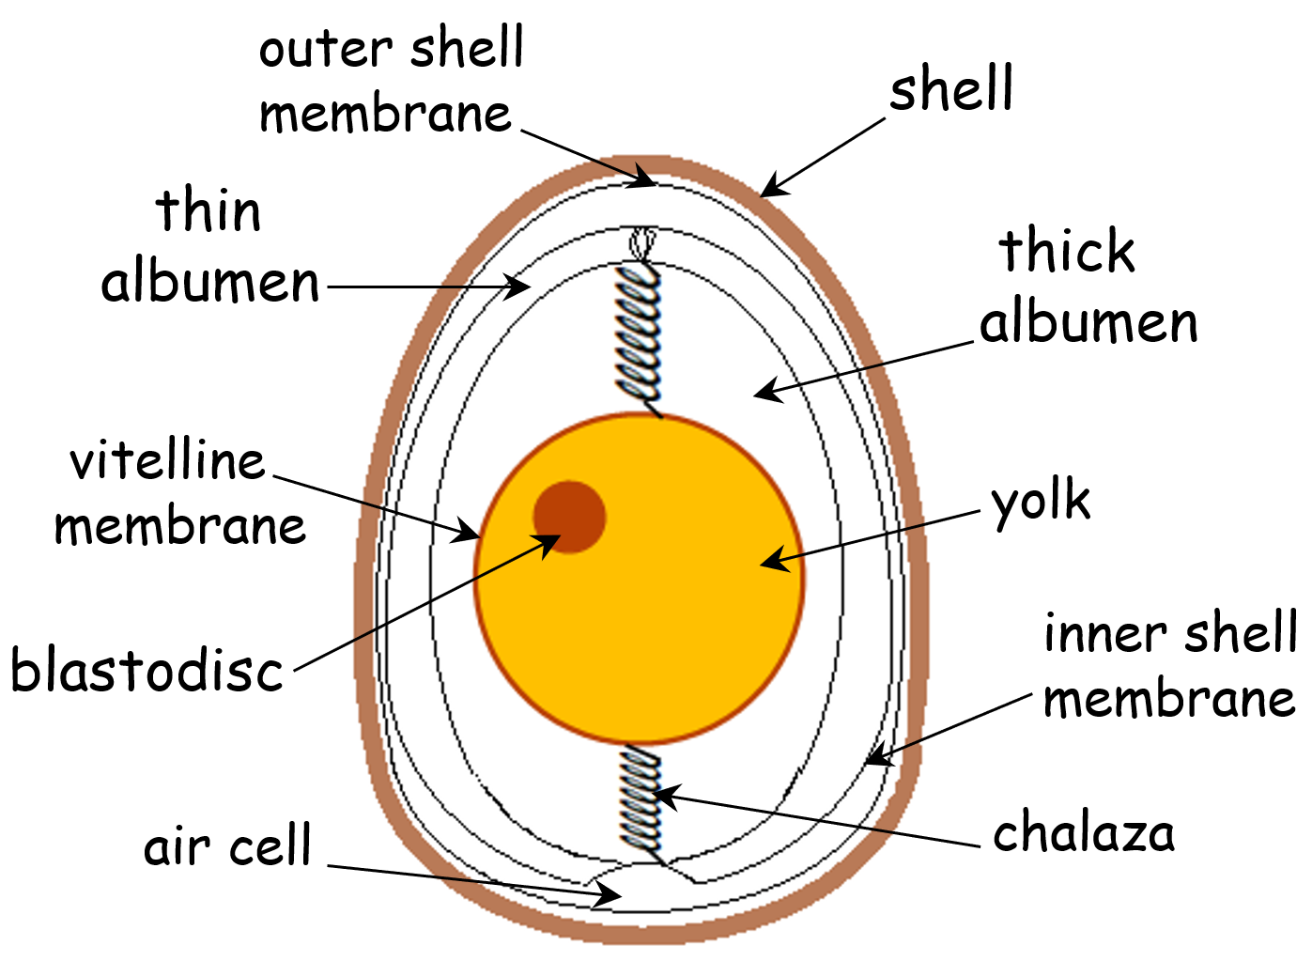
There are 8 parts of a chicken egg:
- Shell. The shell is the hard outer layer of the egg. It is made mostly of calcium carbonate and has thousands of tiny pores that allow far gaseous exchange and water to pass through.
- Outer shell membrane. The outer shell membrane is a thin layer of tissue that lies just inside the shell. It helps to protect the egg from bacteria.
- Inner shell membrane. The inner shell membrane is another thin layer of tissue that lies just inside the outer shell membrane. It helps to keep the egg white and yolk together.
- Albumen. The albumen is the clear, white part of the egg. It is made up of mostly protein and water. The albumen helps to protect the yolk and provides nutrients for the developing embryo.
- Yolk. The yolk is the yellow part of the egg. It is made up of mostly fat, protein, and vitamins. The yolk provides nutrients for the developing embryo.
- Vitelline membrane. The vitelline membrane is a thin layer of tissue that surrounds the yolk. It helps to keep the yolk together.
- Chalazae. The chalazae are two spiral cords that are attached to the yolk. They help to keep the yolk centred in the egg.
- Air cell. The air cell is a small pocket of air that is found at the large end of the egg. It is formed as the egg cools after it is laid. The air cell helps to prevent the egg from sticking to the inside of the shell.
The colour of the eggshell can vary depending on the breed of chicken. The colour of the yolk is also affected by the diet of the hen.
The egg shell:

An eggshell is composed of 95% calcium carbonate, 3.5% protein, and 1.5% other minerals. The calcium carbonate crystals are held together by a network of proteins, including keratin, osteopontin, and ovocleidin. These proteins give the eggshell its strength and flexibility.
Egg shells can be as thin as 0.2 mm for the quails egg all the way up to 2 mm for the Ostrich egg shell. Chicken eggs are between 0.28 mm and 0.4 mm thick. Egg shells have 17000 pores to allow for gaseous exchange.
The main protein found in eggshells is keratin, which is also found in hair, nails, and skin. Keratin is a fibrous protein that gives the eggshell its strength and durability. Other proteins found in eggshells include osteopontin and ovocleidin. Osteopontin helps to bind the calcium carbonate crystals together, while ovocleidin helps to create a protective coating on the eggshell.
Below: Eggs come in many colours.
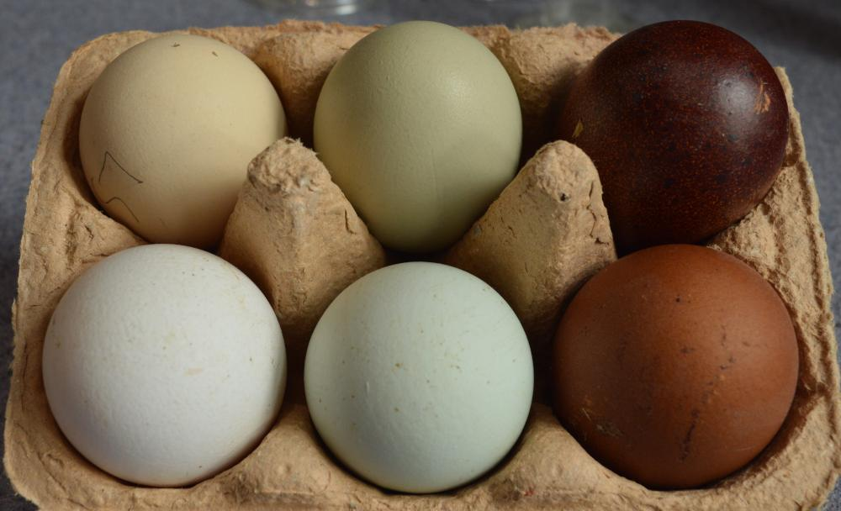
The eggshell also has a thin outermost coating called the cuticle. The cuticle is made of lipids and proteins and helps to protect the eggshell from bacteria and moisture.
The composition of eggshells can vary depending on the species of bird, the diet of the hen, and the environmental conditions. For example, eggshells from chickens that are fed a diet high in calcium will be stronger than eggshells from chickens that are fed a diet low in calcium.
The eggshell plays an important role in protecting the developing chick. It helps to keep the chick safe from bacteria and other harmful microorganisms. It also helps to regulate the chick's temperature and humidity.
Egg membranes:

Egg membranes are the thin layers of tissue that surround the yolk and white of an egg. These membranes are typically 100 nanometers thick.
Below: The membrane in an egg.
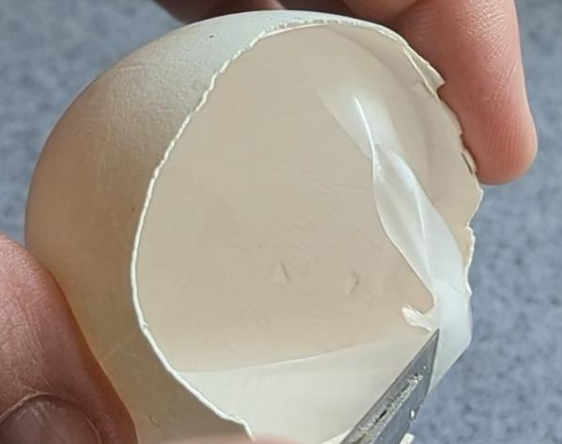
There are three egg membranes:
- The outer membrane is the thinnest and most delicate membrane. It is attached to the inner surface of the eggshell.
- The inner membrane is thicker and stronger than the outer membrane. It helps keep the yolk and white together.
- The vitelline membrane is a thin, transparent membrane that surrounds the yolk of an egg. It is made of proteins and glycoproteins, and it is attached to the outer surface of the yolk.
The membranes are made of a protein called keratin.
The gap between the inner and outer shell membranes allows for the air cells to form as the egg cools after being laid.
These membranes help to protect the egg from bacteria and other harmful microorganisms.

Eggs albumin or egg white:
The egg white, also known as albumen, is the clear, viscous liquid that surrounds the yolk of an egg. It is made up of about 90% water, and the remaining 10% is made up of proteins.
Below: The egg showing the albumen or egg white.
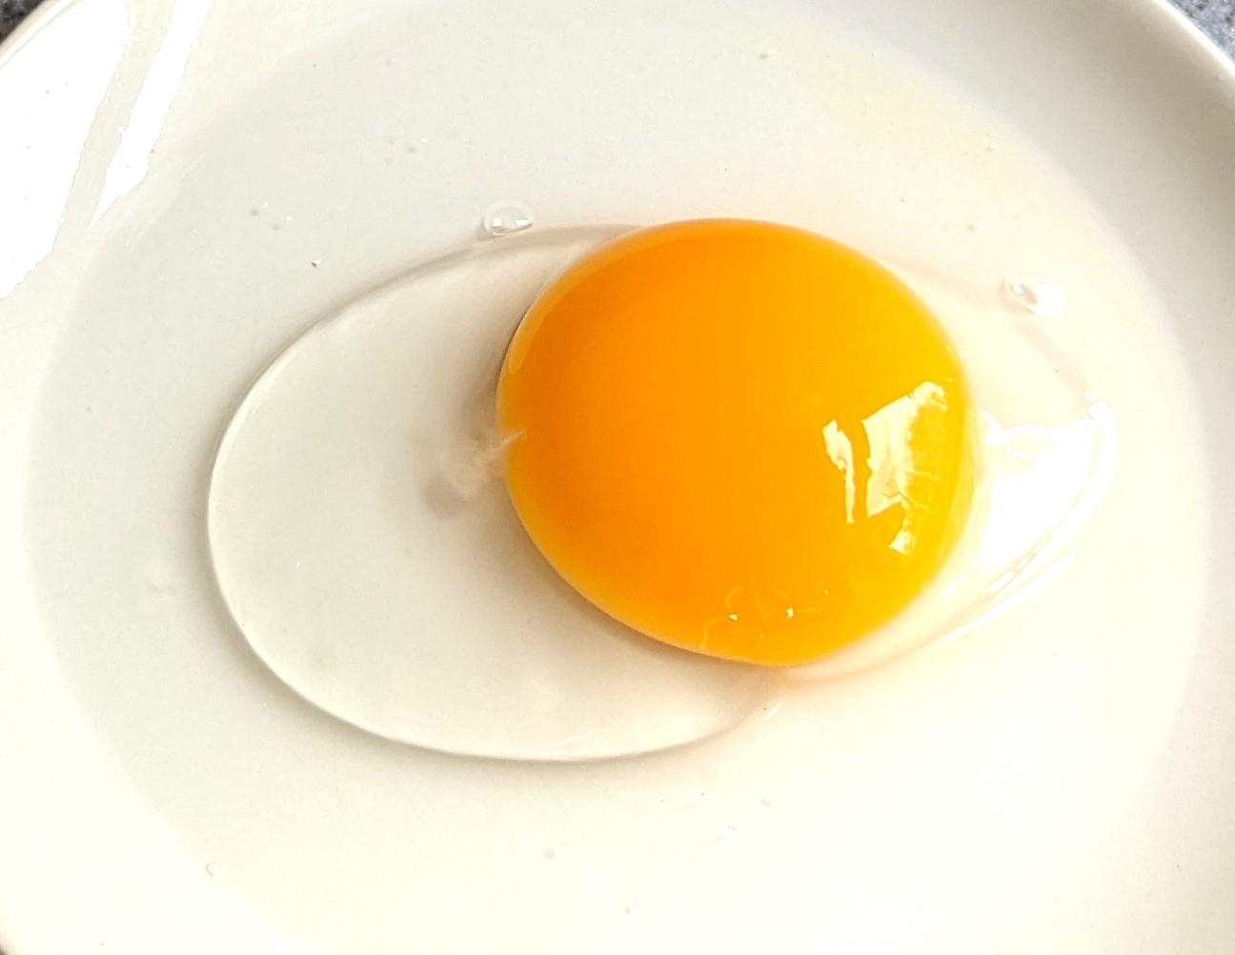
The thick white is the part that is closest to the yolk. It is the most viscous and contains the most proteins.
The thin white is the part that is furthest from the yolk. It is less viscous and contains fewer proteins.

The Yolk:
The yolk of an egg is the yellow, central part of the egg. It is made up of about 50% fat, 30% protein, and 10% water. The remaining 10% is made up of salts, vitamins, minerals, and other nutrients.
The germinal disc or blastoderm is a small, circular area of cells on the surface of the yolk. It is the only part of the egg that will develop into the embryo. The germinal disc is formed when the sperm fertilises the egg.

The chalazae:
The chalazae are two spiral-shaped cords of tissue that are attached to the yolk. They help to keep the yolk centred in the egg.
Below: The fibrous chalazae (plural) chalaza (singular).
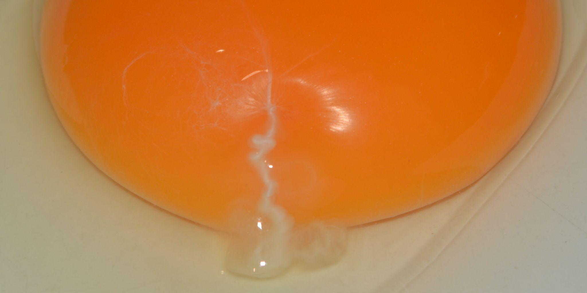
The chalazae are twisted in opposite directions to stop the yolk from rotating.

The air cell:
The air cell in an egg is formed at the round end when the egg is laid. As the egg cools, the white of the egg contracts, leaving a small pocket of air.
The size of the air cell can vary depending on how long the egg has been laid. Freshly laid eggs will have a small air cell, while older eggs will have a larger air cell.
Air cells facilitate gaseous exchange during incubation and provide a reservoir of space and air during the hatching process.

Below: Eggs are around 12% shell, 60% white and 28% yolk.
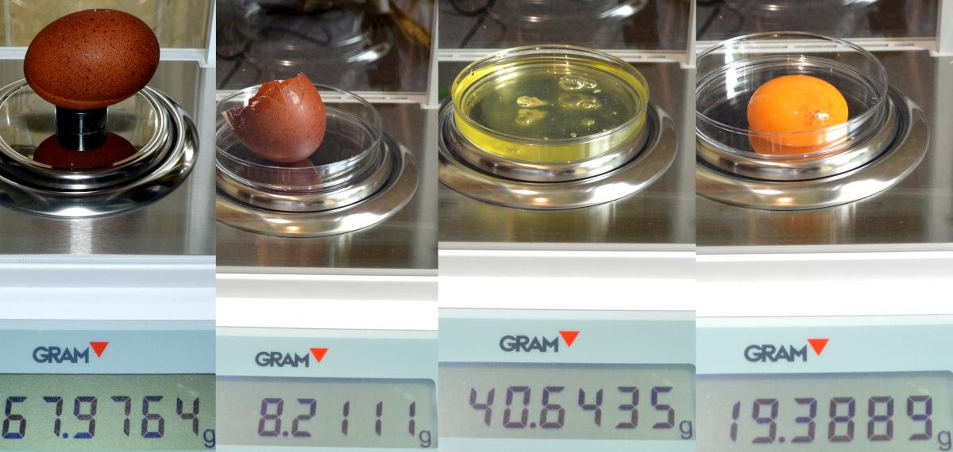
Questions:
1. Calculate the total mass of the constituents of the egg in the image above and compare to the mass of the whole egg.
Suggest a reason for this discrepancy? How could it be avoided in future?
2. Which of these eggs is the freshest?
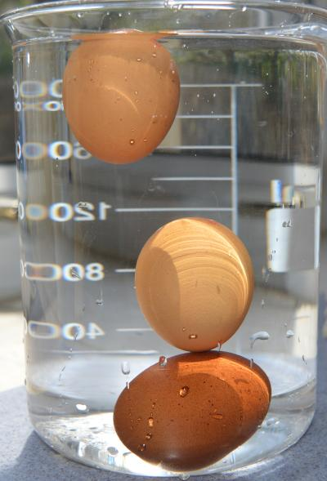
3. Which part of the egg contains the majority of the protein?

Answers:
1. 0.2671g.
Fingerprints, dust contamination.
Wear gloves or use tools to manipulate the samples. Store samples properly.
2. The one at the bottom, it has the smallest air cell.
3. The egg white (albumen) contains the majority of the egg's protein.

This text and images is released under creative commons CC BY, Attribution 4.0 International. This means you are free to use, host, adapt and redistribute this material provided you give credit to https://cluckin.net/authors/neil-armitage/

